Enable edge repository for edge gallery
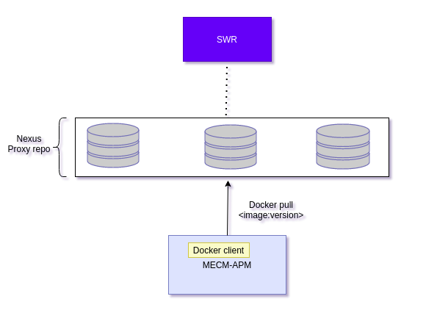

Steps to enable the edge repository

1. Create private repository. Please refer the steps to create docker proxy repository in nexus

2. Deploy the mecm-apm with push_image flag as true

3. Change permission of /var/run/docker.sock to 666
sudo chmod 666 /var/run/docker.sock

Steps to create docker proxy repository in nexus

1. create dir
mkdir -p /nexus/nexus3/data

2. chown -R 200 /nexus/nexus3/data

3. Go to nexus3
cd /nexus/nexus3/

4. create docker-compose.yml file
nexus:
image: sonatype/nexus3:latest
ports:
- "8081:8081"
- "8123:8123"
volumes:
- ./data:/nexus-data

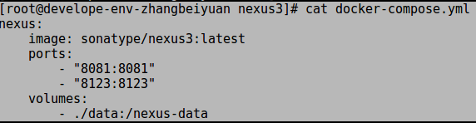

5. Launch nexus:
docker-compose up -d

6. Open the URL [Docker host IP address]:8081 in a web browser

7. Sign in to nexus3
Click the Sign In button in the upper right corner and use the username <admin> and the password.
Initial password can be found in data directory

8. Click proxy repository

a. Click on cogwheel

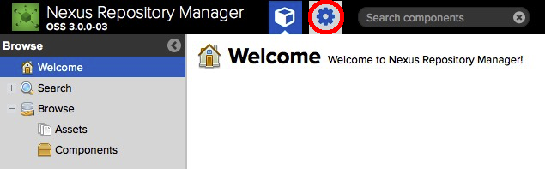

b. Click on repository

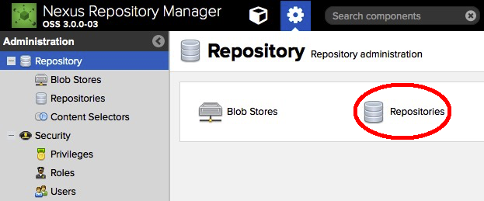

c. Click on create repository

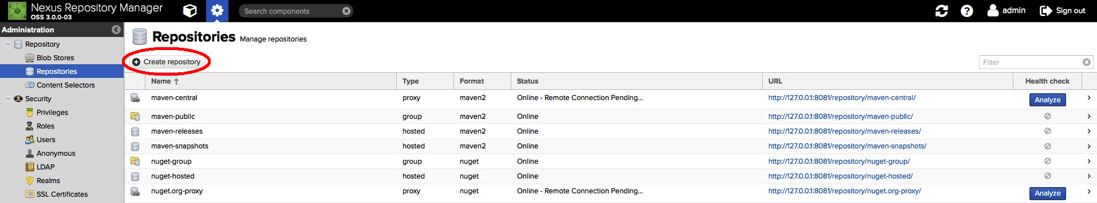

d. click on docker proxy

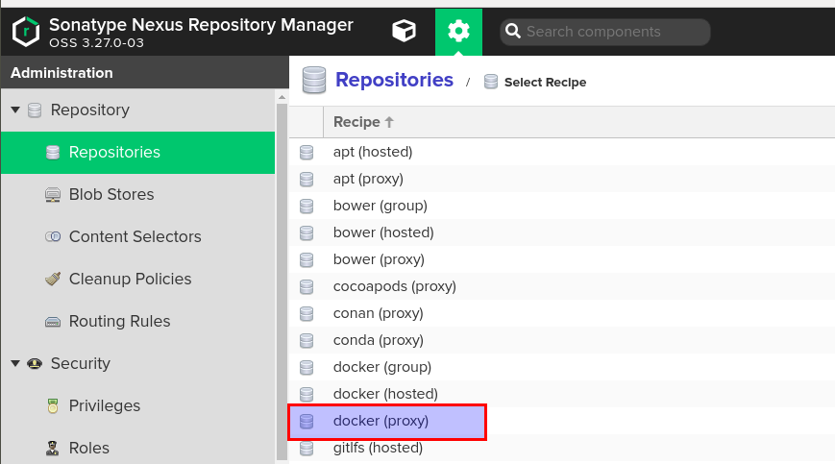

e. Configure proxy repo

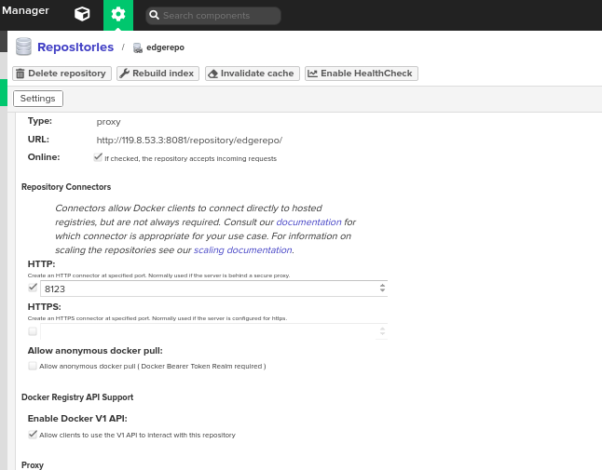

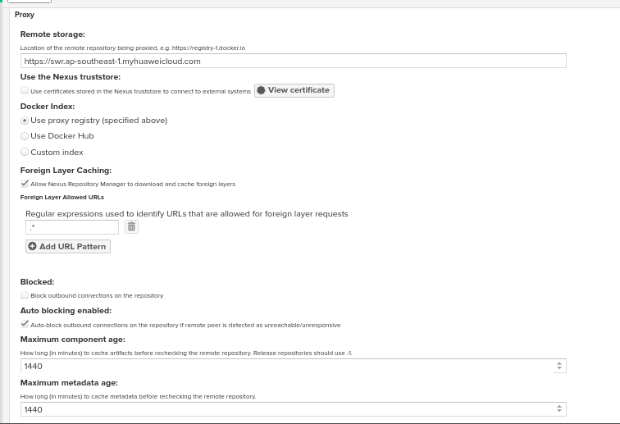

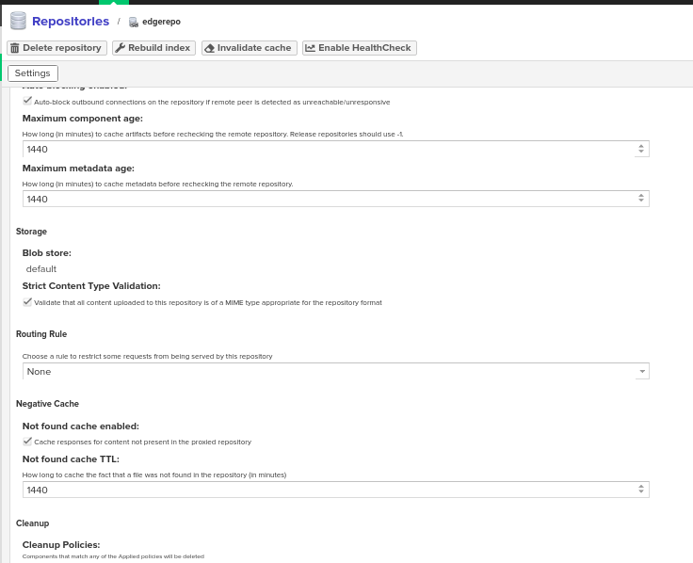

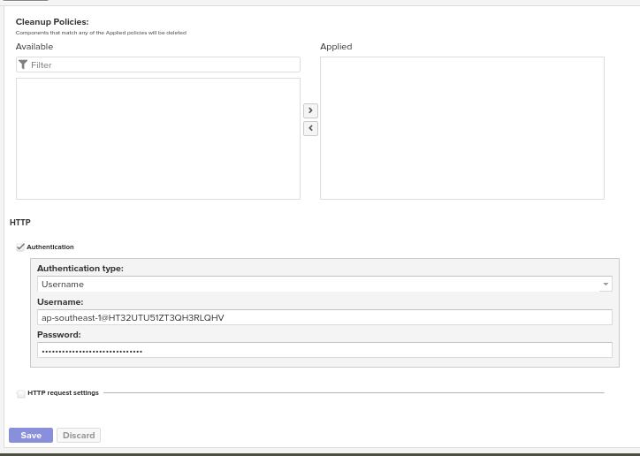

9. Configure insecure registry in /etc/docker/daemon.json and restart docker service

{
"insecure-registries":["<ip>:<port>"]
}

ip where nexus repo is installed and port configured in the proxy repo

Commands to restart docker service

sudo systemctl daemon-reload
sudo systemctl restart docker

10. login to docker registry

docker login -u <username> -p <password> <ip:port>
docker pull/push <ip:port>/<imagename:version>

